Cloud Deployable Collegiate Cyber Defense Competition Practice Range

Charles Danner
Whatcom Community College
CIS 405 - Cloud Computing
Kathleen Czurda-Page
3/25/2026
Cloud Deployable Collegiate Cyber Defense Competition Practice Range

Original Project Definition
The goal was to build a practice environment that looked and felt like a real Collegiate Cyber Defense Competition (CCDC) network and could be deployed repeatedly on demand. The five week plan covered installing Ludus on a local Proxmox server, building a small range, expanding to a medium range, adding blue and red team components, and finishing with documentation. The primary tools listed in the proposal were Proxmox, Ludus, Ansible, and Claude Code. The final deliverable was a working demo and a teaching walkthrough.
Changes Made During the Project
The project was completed on schedule but the scope grew beyond the original proposal. The most significant addition was a custom scoring engine, which was not planned at the start. At a real CCDC competition, an automated system checks whether services are still running and awards points for uptime (Sshell, 2025). Adding one to the practice range made training much more realistic. A referee toggle was also added to the scoring dashboard to hide IP addresses and check details from the blue team during sessions, which reflects how real competitions work. The range stayed on local Proxmox hardware rather than being moved to a cloud provider, since local hardware was faster and more practical for development.
Final Scope
By the end of the project the following was completed: Ludus installed and running on a local Proxmox host, a Windows Active Directory domain with a domain controller and a Windows 11 workstation, five Linux service machines running web, database, file sharing, mail, and FTP services, a Kali Linux attacker machine loaded with a full penetration testing toolset, a custom Python based scoring engine that checks eleven services every thirty seconds, a live web dashboard showing service status and uptime history, and a referee toggle to hide diagnostic details from blue team players (Western Regional CCDC, n.d.). All nine virtual machines are spread across two isolated networks and configured entirely through Ansible roles stored in the project repository.
Key Decisions and Why
The most important decision was to use Ansible roles for all configuration rather than setting up machines by hand. Without Ansible, rebuilding the range would require manually touching each of the nine virtual machines every time, which would take hours and produce inconsistent results. Ansible makes the environment fully repeatable and allows a complete rebuild from scratch with a single command.
The choice to use Ludus as the base platform was equally important. Ludus handles creating virtual machines from templates, placing them on the correct virtual networks, and calling the Ansible roles automatically. Without Ludus, all of that provisioning logic would have needed to be built from scratch. Running a full system upgrade before installing tools on the Kali Linux machine was a decision made after package dependency errors blocked installation. Upgrading the system first resolved all conflicts reliably.
Tools and Software Used
Proxmox Virtual Environment is the hypervisor that runs all of the virtual machines in the range. It handles creating and managing VMs and provides the virtual networking that keeps the corporate network and the attacker network separated.
Ludus Cyber Range sits on top of Proxmox and automates range creation. Ludus reads the YAML configuration file, creates each machine from a template, places it on the correct network, and hands off to Ansible to finish configuration. Ludus is what makes a single command rebuild possible (Ludus, n.d.).
Ansible configures each virtual machine after it is created. The ten Ansible roles written for this project cover every machine in the range, from the domain controller to the FTP server. Ansible makes the configuration repeatable because it always runs the same steps in the same order from files stored in the repository.
Claude Code was used to write and debug the Ansible roles and the Ludus configuration file. Writing roles for Windows Active Directory and multiple Linux services involves many tasks, module options, and edge cases. Claude Code generated role structure, suggested fixes when tasks failed, and translated competition service requirements into working Ansible code. It made completing all ten roles within the project timeline possible.
Diagrams
Figure 1 below shows the full network layout of the range. It includes the Debian router that connects the WAN, VLAN 10, and VLAN 99, along with each virtual machine labeled with its IP address, operating system, purpose, and key ports.
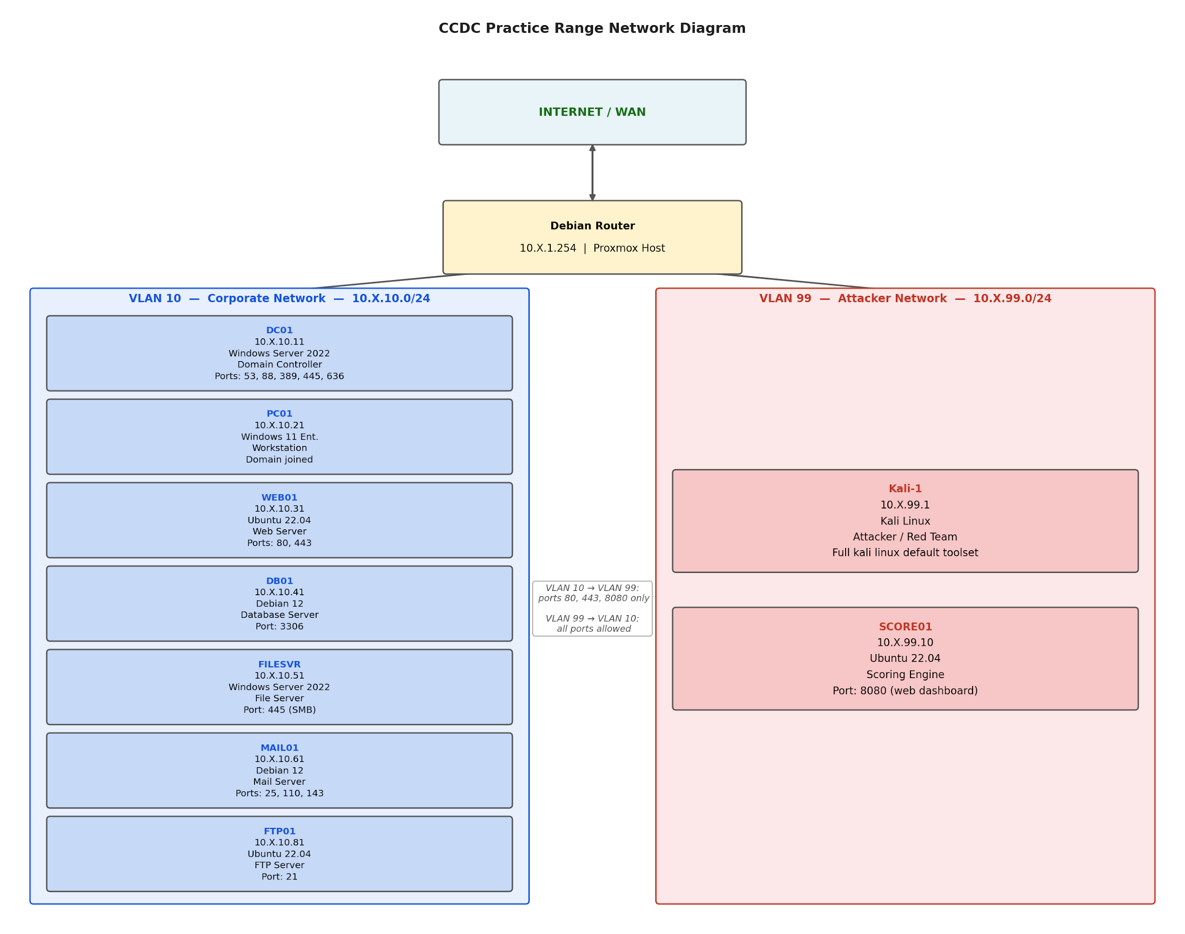
Figure 1. CCDC Practice Range Network Diagram
Code and Configuration Steps
All configuration files live in the project repository. The main range configuration file defines every virtual machine, its VLAN, its IP address, and which Ansible roles to run on it. The ten Ansible roles are in the roles folder, one subfolder per machine. Each role subfolder contains a tasks file with the configuration steps, a defaults file with variable defaults, and a templates folder with config files for services like Apache, Postfix, and the scoring engine. No configuration is done by hand and every setting is driven by these files.
Installation and Deployment Instructions
Prerequisites
A running Ludus host (v1.5+). If you have not installed Ludus yet, follow the Ludus quick start guide.
The following five templates must be built before the range can be deployed:
win2022-server-x64-template
win11-22h2-x64-enterprise-template
debian-12-x64-server-template
ubuntu-22.04-x64-server-template
kali-x64-desktop-template
Step 1: Build the Required Templates
Ludus builds templates from scratch using Packer and ISO files. On a fresh install none are built yet. For full details on how templates work see the Ludus templates documentation.

Check what is already built:

ludus templates list
Any template showing NOT BUILT needs to be built before you continue.

Build all five templates at once:

ludus templates build -n win2022-server-x64-template
ludus templates build -n win11-22h2-x64-enterprise-template
ludus templates build -n debian-12-x64-server-template
ludus templates build -n ubuntu-22.04-x64-server-template
ludus templates build -n kali-x64-desktop-template
Each template build takes roughly 15 to 45 minutes depending on your hardware and internet speed. Windows templates take longer than Linux ones.

Monitor the build progress:

ludus templates logs -f
Or check status at any time with:

ludus templates status
You can also watch builds in the Proxmox web UI at https://<ludus-ip>:8006. Get your Proxmox credentials with:

ludus user creds get
Wait until all five templates show as built before continuing:

ludus templates list
All five should show a green checkmark before you move on to the next step.

Step 2: Clone this Repository on your Ludus host
git clone <repo-url> ~/Ludus-AD-Range-Configured
cd ~/Ludus-AD-Range-Configured
Step 3: Add all Ansible roles to Ludus
Each role must be registered with Ludus before it can be used in the range config:

ludus ansible role add -d roles/ludus_ccdc_web_server
ludus ansible role add -d roles/ludus_ccdc_db_server
ludus ansible role add -d roles/ludus_ccdc_file_server
ludus ansible role add -d roles/ludus_ccdc_mail_server
ludus ansible role add -d roles/ludus_ccdc_ftp_server
ludus ansible role add -d roles/ludus_ccdc_workstation
ludus ansible role add -d roles/ludus_ubuntu_desktop
ludus ansible role add -d roles/ludus_ccdc_scoring_engine
ludus ansible role add -d roles/ludus_ccdc_domain_users
ludus ansible role add -d roles/ludus_ccdc_kali_setup
Verify roles are installed:

ludus ansible role list
Step 4: Set the range configuration
ludus range config set -f range-config.yaml
Step 5: Deploy the range
ludus range deploy
To deploy only the custom roles (e.g., after modifying a role):

ludus range deploy -t user-defined-roles
To deploy a specific role to a specific VM:

ludus range deploy -t user-defined-roles --limit <VM_NAME> --only-roles <ROLE_NAME>
Roles Overview
Role VM OS Service Ports
ludus_ccdc_web_server WEB01 Ubuntu 22.04 Server Apache + PHP 8.1 + Company Portal 80/tcp
ludus_ccdc_db_server DB01 Debian 12 MariaDB/MySQL 3306
ludus_ccdc_file_server FILESVR Windows Server 2022 SMB Shares 445
ludus_ccdc_mail_server MAIL01 Debian 12 Postfix + Dovecot 25, 110, 143
ludus_ccdc_ftp_server FTP01 Ubuntu 22.04 vsftpd 21
ludus_ccdc_workstation PC01-W11 Windows 11 Blue team tools via Chocolatey (Wireshark, Burp Suite, Process Hacker, etc.) —
ludus_ubuntu_desktop SCORE01 Ubuntu 22.04 XFCE4 desktop environment + LightDM —
ludus_ccdc_scoring_engine SCORE01 Ubuntu 22.04 Flask scoring engine + SQLite + systemd 8080
ludus_ccdc_domain_users DC01-2022 Windows Server 2022 Creates Ludus Corp employee AD accounts + DNS A records + DNS vulns 53
ludus_ccdc_kali_setup kali-1 Kali Linux Installs kali-linux-default tool metapackage —
Updating a Role
Important: ludus range deploy always uses the role files that were installed into Ludus at the time you ran ludus ansible role add. If you git pull changes to this repo and then redeploy without re-running ludus ansible role add, the deployed VM will still use the old (stale) role files. Always re-add a role after pulling updates, before redeploying.

# Re-add the changed role, then redeploy only that VM
ludus ansible role add -d roles/ludus_ccdc_web_server
ludus range deploy -t user-defined-roles --limit {{ range_id }}-WEB01 --only-roles ludus_ccdc_web_server
To re-add and redeploy all roles at once (e.g. after a fresh clone or after pulling multiple changes):

ludus ansible role add -d roles/ludus_ccdc_web_server
ludus ansible role add -d roles/ludus_ccdc_db_server
ludus ansible role add -d roles/ludus_ccdc_file_server
ludus ansible role add -d roles/ludus_ccdc_mail_server
ludus ansible role add -d roles/ludus_ccdc_ftp_server
ludus ansible role add -d roles/ludus_ccdc_workstation
ludus ansible role add -d roles/ludus_ubuntu_desktop
ludus ansible role add -d roles/ludus_ccdc_scoring_engine
ludus ansible role add -d roles/ludus_ccdc_domain_users
ludus ansible role add -d roles/ludus_ccdc_kali_setup
ludus range deploy -t user-defined-roles
References

Ludus. (n.d.). Introduction to Ludus. https://docs.ludus.cloud/docs/intro/
Ludus. (n.d.). Quick start guide. https://docs.ludus.cloud/docs/quick-start/
Sshell. (2025). Red teaming at national CCDC 2025. https://www.sshell.co/red-teaming-at-national-ccdc-2025/
Western Regional CCDC. (n.d.). WRCCDC VM image archive. https://archive.wrccdc.org/images/
Winterknight. (n.d.). How to win CCDC. https://www.winterknight.net/how-to-win-ccdc/

